# Project Design Phase-II Technology Stack (Architecture & Stack)

|  |  |
| --- | --- |
| Date | 18 October 2022 |
| Team ID | PNT2022TMID24238 |
| Project Name | Project – Industry-Specific intelligent fire management system |
| Maximum Marks | 4 Marks |

**Technical Architecture:**

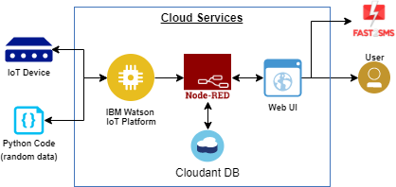

**Guidelines:**

1. Include all the processes (As an application logic / Technology Block)
2. Provide infrastructural demarcation (Local / Cloud)
3. Indicate external interfaces (third party API’s etc.)
4. Indicate Data Storage components / services
5. Indicate interface to machine learning models (if applicable)

# Table-1 : Components & Technologies:

|  |  |  |  |
| --- | --- | --- | --- |
| **S.No** | **Component** | **Description** | **Technology** |
| 1. | User Interface | Web UI, Node-RED, MIT app | IBM IoT Platform, IBM Node red, IBM Cloud |
| 2. | Application Logic-1 | Create IBM Watson IoT platform and create node- red service | IBM Watson, IBM cloud service ,IBM node-red |
| 3. | Application Logic-2 | Develop python script to publish and subscribe to IBM IoT Platform | python |
| 4. | Application Logic-3 | Build a web application using node-red service | IBM Node-red |
| 5. | Database | Data Type, Configurations etc. | MySQL |
| 6. | Cloud Database | Database Service on Cloud | IBM DB2, IBM Cloudant |
| 7. | File Storage | Developing mobile application to store and receive the sensors information and to react accordingly | Web UI ,Python |
| 8. | External API-1 | Using this IBM fire management API we can track the temperature of the incident place and where the fire had been attacked. | IBM fire management API |
| 9. | External API-2 | Using this IBM Sensors it detects the fire, gas leaks , temperature and provides the activation of sprinklers to web UI | IBM Sensors |
| 10. | Machine Learning Model | Using this we can derive the object recognition model | Object Recognition Model |
| 11. | Infrastructure (Server / Cloud) | Application Deployment on Local System / Cloud Server Configuration | IBM cloudant, IBM IoT Platform |

**Table-2: Application Characteristics:**

|  |  |  |  |
| --- | --- | --- | --- |
| **S.No** | **Characteristics** | **Description** | **Technology** |
| 1. | Open-Source Frameworks | MIT app Inventor | MIT License |
| 2. | Security Implementations | IBM Services | Encryptions, IBM Controls |
| 3. | Scalable Architecture | sensor-IoT Cloud based architecture | cloud computing and AI |
| 4. | Availability | Mobile, laptop, desktop | MIT app |
| 5. | Performance | Detects the Fire, gas leak, temperature | sensors |